Cascade training report
Working package 3.2 Cascade training for the sharing of EU experience

On June 08th, 2021 (Tuesday) we had cascade training for 41 staff, Lecturers of the School of Information and Communication Technology, Academic affairs specialists, IT Engineers, and engineers from the Cloud university consortium. We have discussed research activities at the Riga Technical University and DDMP Curriculum.

WP 3.2. PC teachers’ training abroad
Date: 1-3, 8-9.04.2021
Riga Technical University, Latvia

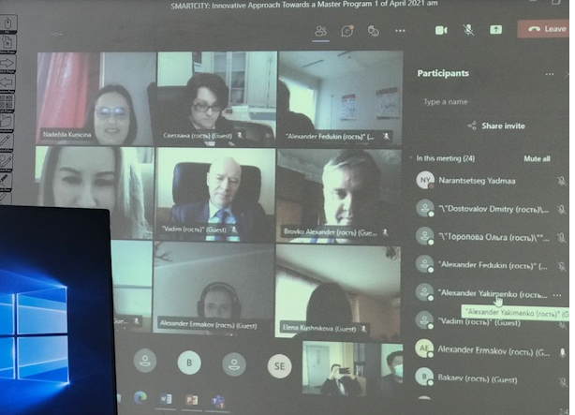

The date of the cascade training: 2021.06.08
The speakers: NARANTSETSEG Yadmaa, BATDORJ Davaagombo
The target group: MUST level training.
The number of the participants: 41

The list of the participants:
