Summer School Report

Working package 3.4 Summer School
SMARTCITY: Innovative Approach Towards a Master Program on Smart Cities Technologies/SMRCITY Activity 3.4 Summer School was organized on 25-29 October 2021 by universities of Mongolia MUST and NUM. A total of 72 professors, lecturers, researchers, and students actively participated in this Summer School.

WP 3.4. Summer School
Date: 25.10.2021-29.10.2021
Mongolian University of Science and Technology & National Universriy of Mongolia

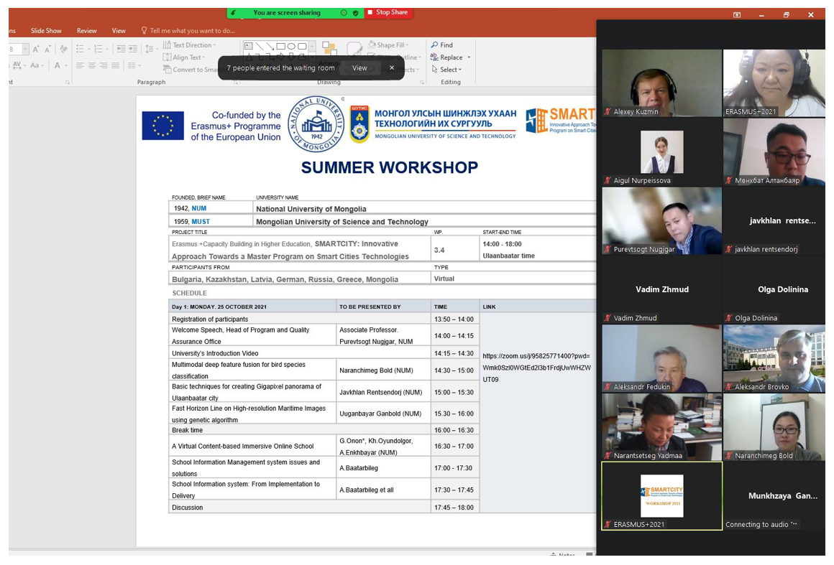

The speaker: NARANTSETSEG Yadmaa, MUST
The speaker: OYUN-ERDENE Namsrai, NUM

The target group: EU and PC Universities staff
The number of the participants: 72

The list of the participants:
